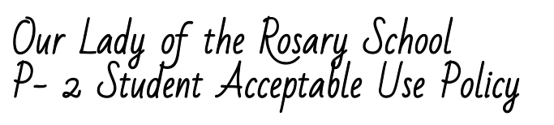
Being an Academic, Caring and Christian Digital Citizen:
In our school we use information and technology to help us with our learning.
We are learning to be safe and responsible digital citizens.

Recognise intellectual property
- I understand that my digital work belongs to me and I only use my own username, files and accounts when using technology.
Apply digital information security practices
- I talk to my teachers and parents about on line security.
- I ask for help when I am not sure what to do.
- I go to a trusted adult for help if I come across sites that are not appropriate or feel agreements are not being followed.
Apply personal security protocols
- I only go online when my parents or an adult know where I am going and can supervise me.
- I keep my personal information safe.
- I am kind to others on-line.
Investigate, create and communicate with ICT
- I follow the teacher’s instructions and class rules when using computers and other technology.
- I use computers and iPads to help me learn.
- I handle equipment with care.
Consequences for Violations
I understand and will follow this Acceptable Use Policy.
If I break this agreement, the consequences could include suspension of computer privileges and/or disciplinary action.
I also understand that my school network accounts are owned by Our Lady of the Rosary School and are for my learning.
OLR has the right to access my information at any time.
Student’s Name (please print): ________________________________
Student’s Signature: _________________________________________ Date: _______________

As the parent or guardian of this student, I have read the Acceptable Use Policy.
I understand that technology is provided for learning in keeping with the academic goals of Our Lady of the Rosary School. I recognise it is impossible for the school to restrict access to all controversial materials, and I understand that there is a shared responsibility between the school, myself and my child in developing safe and appropriate use. I understand that children’s computer activities at home should be supervised. I understand that I may be responsible for replacing any school property that has been willfully damaged.
I hereby give permission for my child to use technology resources at OLR.
Parent or Guardian’s Name (please print): ________________________________
Parent or Guardian’s Signature: ______________________________ Date: _______________

