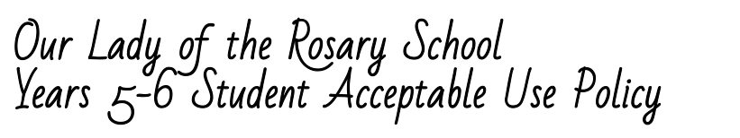
Being an Academic, Caring and Christian Digital Citizen:
In our school we use information and technology in safe, legal, and responsible ways.
We embrace the following aspects of being a digital citizen. I will:
Recognise intellectual property
- Use the technology at school to help me learn and not interfere with the work or data of another student.
- Think critically about what I read and view on the Internet. Question if it is from a reliable source and use the information to help me answer any questions (I should not copy and paste the information as my answer).
- Respect the ownership of information (including images) on school computers. This includes not copying photos/images for personal use without permission.
- Not bring or download unauthorised programs, including games, to the School or run them on school computers.
Apply digital information security practices
- Keep myself and my friends safe by not giving out personal details including full names, telephone numbers, addresses and images.
- Talk to my teacher or another adult if I need help online or I am not sure what to do.
- Think before I post online – once posted it is difficult to remove things.
- Leave a site immediately by clicking ‘back’ or closing the browser, if I feel uncomfortable.
- Not open emails, documents, downloads or pop ups etc. from unknown sources.
Apply personal security protocols
- Go to a teacher, parent or another trusted adult if I need help; if I come across sites that are not appropriate or material that is not acceptable; or if I think that any of the agreements are not being followed.
- Not reveal my password except to the system administrator or a teacher if required.
- Not respond if someone sends me an unkind or offensive message. Instead, tell a teacher, parent or another trusted adult.
- Search for sites as directed by the teacher and not go looking for rude or offensive sites.
- Respect the privacy of others when using technology.
- Always be aware that while the School uses software and filters to keep our community safe there may be times when I see inappropriate material and I need to tell an adult if this happens.
Investigate, create and communicate with ICT
- Be respectful in how I talk to and work with others online and never write or participate in online bullying (cyber bullying, text bullying etc.) even if it is meant as a joke.
- Always use language and images that would be acceptable at school.
- Always use technology in a manner which reflects the OLR academic, caring and Christian core values.
- Use mobile devices at the discretion of the supervising teacher and in line with class and school rules.
- Not use mobile devices to record or capture images of others without their knowledge and permission.
- Not buy or sell items or services over the internet.

Consequences for Violations:
I understand and will follow this Acceptable Use Policy.
If I break this agreement, the consequences could include suspension of computer privileges and/or disciplinary action. I also understand that my school network and e-mail accounts are owned by OLR and are not private.
OLR has the right to access my information at any time.
Student’s Name (please print): ________________________________
Student’s Signature: ________________________________ Date: _______________

As the parent or guardian of this student, I have read the Acceptable Use Policy.
I understand that technology is provided for learning in keeping with the academic goals of OLR. I recognise it is impossible for the school to restrict access to all controversial materials, and I understand that there is a shared responsibility between the school, myself and my child in developing safe and appropriate use.
I understand that children’s computer activities at home should be supervised. I understand that I may be responsible for replacing any school property that has been willfully damaged.
I hereby give permission for my child to use technology resources at OLR.
Parent or Guardian’s Name (please print): ________________________________
Parent or Guardian’s Signature: ______________________________ Date: _______________

