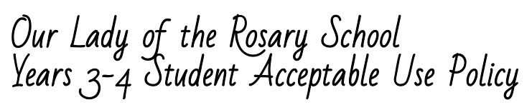
Being an Academic, Caring and Christian Digital Citizen:
In our school we use information and technology in safe, legal, and responsible ways.
We embrace the following aspects of being a digital citizen. I will:
Recognise intellectual property
- Always be an honest user of information and show where I found my information (I should not copy and paste the information as my answer).
- Think carefully about what I read and view on the Internet and question whether I should believe it or not.
- Respect the ownership of information (including images) on school computers. This includes not copying photos/images for personal use without permission.
Apply digital information security practices
- Keep myself and my friends safe by not giving out personal details including full names, telephone numbers, addresses and images.
- Not bring or download unauthorised programs, including games, to the school or run them on school computers.
- Leave a site immediately by clicking ‘back’ or closing the browser, if I feel uncomfortable.
- Not open emails, documents, downloads or pop ups from unknown sources.
Apply personal security protocols
- Not to reveal my password except to the system administrator or a teacher if required.
- Go to a teacher, parent or another trusted adult if I need help; if I come across sites that are not appropriate or material that is not acceptable; or if I think that any of the agreements are not being followed.
- Search for sites as directed by the teacher and not go looking for rude or offensive sites.
- Talk to my teacher or another adult if I need help online or I am not sure what to do. Always be aware that while the School uses software and filters to keep our community safe, there may be times when I see inappropriate material and I need to tell an adult if this happens.
Investigate, create and communicate with ICT
- Use the technology at school to help me learn.
- Always talk to others online in the way I would like to be spoken to myself.
- Never participate in bullying others online and report concerns immediately to a trusted adult.
- Always use technology in a manner which reflects the OLR academic, Christian and caring core values.
- Use mobile devices and other technology only with the permission of my teacher and in line with class and school rules.
- Not use mobile devices to record or capture images of others without their knowledge and permission.
- Handle technology responsibly and with respect

Consequences for Violations
I understand and will follow this Acceptable Use Policy.
If I break this agreement, the consequences could include suspension of computer privileges and/or disciplinary action. I also understand that my school network and e-mail accounts are owned by Our Lady of the Rosary School and are for my learning. OLR has the right to access my information at any time.
Student’s Name (please print): ________________________________
Student’s Signature: ________________________________ Date: _______________

As the parent or guardian of this student, I have read the Acceptable Use Policy.
I understand that technology is provided for learning in keeping with the academic goals of OLR. I recognise it is impossible for the School to restrict access to all controversial materials, and I understand that there is a shared responsibility between the School, myself and my child in developing safe and appropriate use. I understand that children’s computer activities at home should be supervised. I understand that I may be responsible for replacing any school property that has been willfully damaged.
I hereby give permission for my child to use technology resources at OLR.
Parent or Guardian’s Name (please print): ________________________________
Parent or Guardian’s Signature: ______________________________ Date: _______________

